For this lesson, we will be using the online program Desmos to determine area under a curve. We have already gone over how to integrate a variety of functions, so today we will be using technology to visualize and solve for area bounded by specific functions or regions. To find the area is simply to find the appropriately bounded integral of the function you are given.

What does area under a curve mean?

Area under a curve means the area above the x-axis but below the given function. We have already gone over how to integrate a variety of functions, so today we will be using technology to visualize and solve for area bounded by specific equations or regions. To find the area is simply to find the appropriately bounded integral of the function you are given.

Let’s try it:

- Find the area under the curve $f(x)=x^{2}+2$ bounded by x=-1, x=2, and the x-axis.

To do this, we will complete the following steps:

To begin, type www.desmos.com into your search engine and click “graphing calculator.”

Step 1: Determine your bounds and function and type them each into a separate line in Desmos.

Here, we are told that our function is $f(x)=x^{2}+2$. We are also told that there are two x-bounds, which are x=-1 and x=2. Lastly, we know that the final bound is the x-axis which is also known as y=0. When we type four equations into Desmos, this is what we should see:

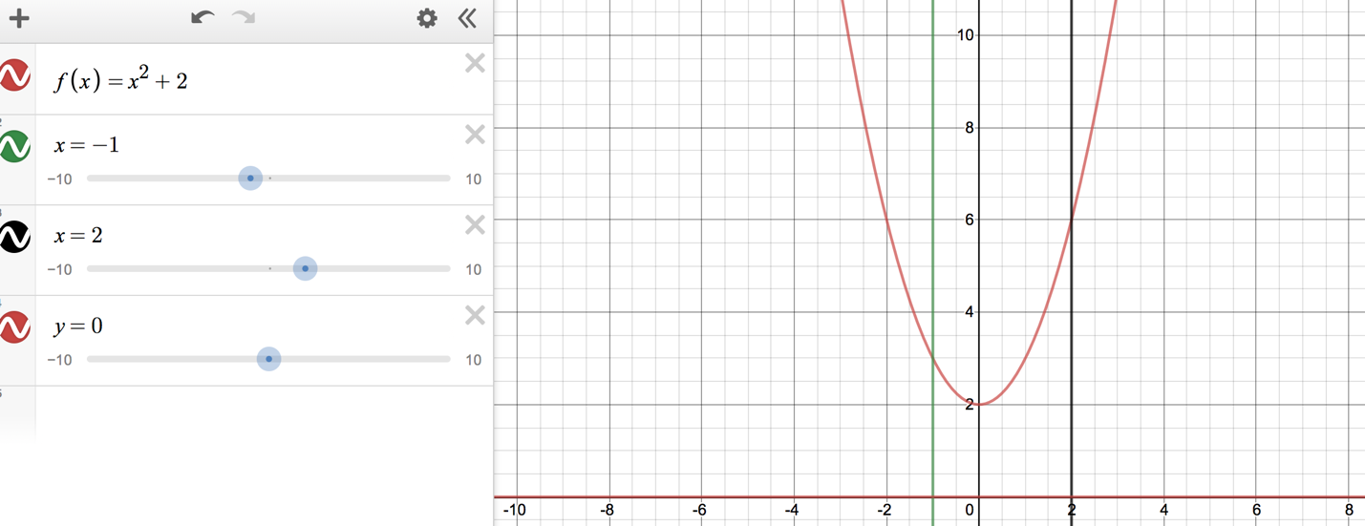

Step 2: Shade the bounded region.

Now that we have our function and bounds graphed, we want to shade the region bounded by these restrictions to better visualize the area we are solving for. We will do this by creating inequalities that describe the range of values that bound both the x and y.

Starting with the y, we see that the lower y value is y=0, but the upper y value is any point along the function $f(x)=x^{2}+2$. We represent this in inequality as $0≤y≤f(x)$.

Next, when we find the region x encompasses, we see that we have bounds of x=-1 and x=2, and since we are looking for the area between those two lines, the inequality we get is $-1≤x≤2$.

We will now type this into Desmos in the next empty line as the following: $0≤y≤f(x)$ {$-1≤x≤2$}
When we do this, our graph looks like this:

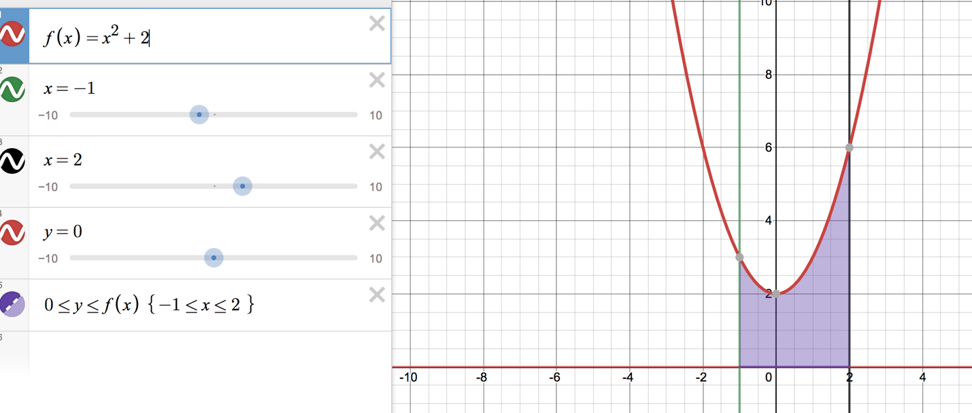

Step 3: Solve for the area, then use Desmos to check your answer.

When we perform definite integrations, we are finding the area under the curve from one value to another. We must figure out what those values are. Here, with the help of our shaded region, we see that the bounded region is from x=-1 to x=2, so those are the bounds we will attach to the integral. In the next empty line in Desmos, type in the following to obtain the area (to get the integral sign, click the functions tab then click “misc” and you should see the sign):
$$\int_{-1}^{2}{\left(f(x)\right)dx}$$
When we do this, our answer will appear in that box. In this case, our area is 9 units. This is what we see when we do this:
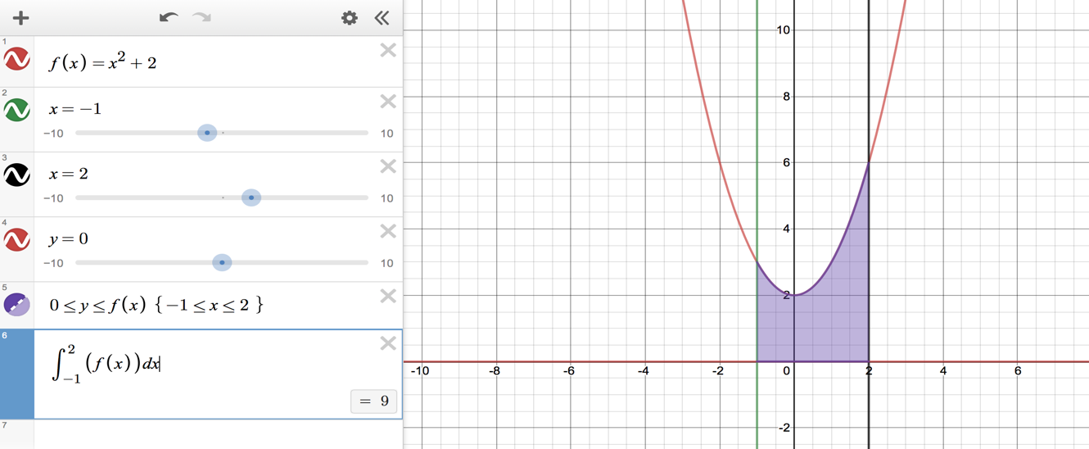

- Find the area under the curve of $g(x)=\frac{1}{2}x+3$ bounded by x=-6, x=6, and the x-axis.

Step 1: Determine your bounds and function and type each individual one into a separate line in Desmos.

Function: _______________

Bounds: ________________

Step 2: Shade the bounded region.

Inequality for y: ______________

Inequality for x: ______________

What you will type into Desmos: ___________________

Step 3: Solve for the area, then use Desmos to check your answer.

Integral you will type into Desmos: _______________

Answer: ______________ units

